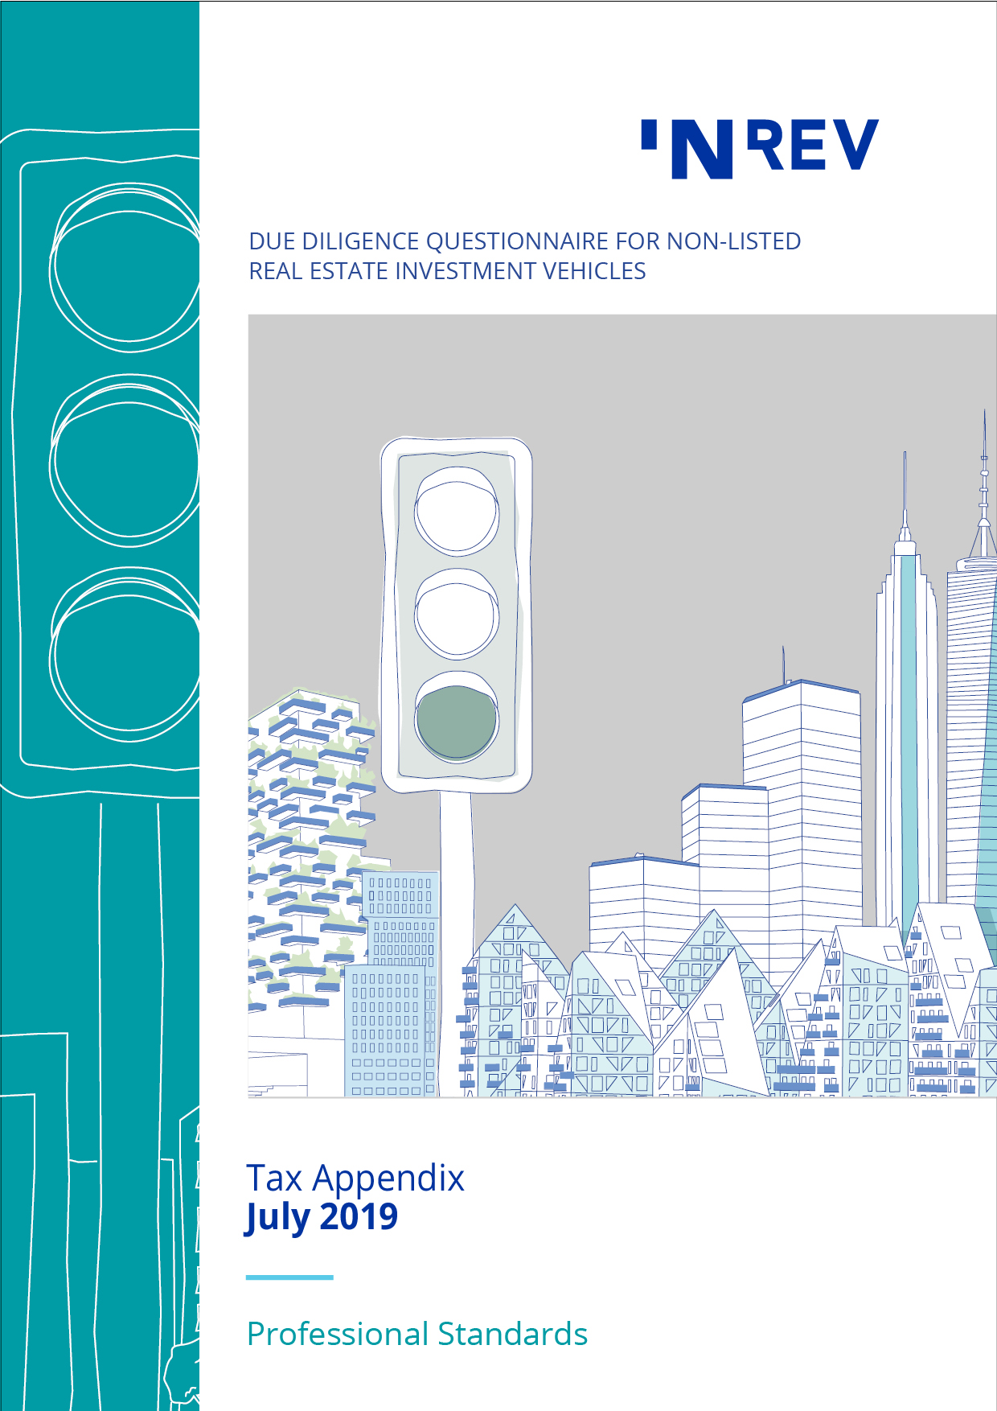

August 2014
Contents

1 Specific questions on taxation 3
2 Specific questions for US investors 12
3 Specific questions for German investors 14

1 Specific questions on taxation

1.1 General questions

1.1.1 Which tax advisors does the investment manager use for (a) tax structuring advice, and (b) tax compliance?

1.1.2 If an in-house tax team is present, please describe how the team is composed (e.g. number of people, roles, level of experience).

1.1.3 If an in-house tax team is present, how is this tax team embedded within the group (e.g. tax director, CFO responsibility, legal & tax department, etc.)?

1.1.4 How is tax compliance managed by the investment manager (to what extent conducted in-house and to what extent outsourced to a service provider)?

1.1.5 What measures does the [vehicle/investment manager] have in place to ensure avoidance of double taxation, use of tax incentives aligned with the business, tax compliance and risk control?

1.1.6 How does the investment structure have impact on the (projected) returns? Please elaborate on expected gross – and net return.

1.1.7 Please describe the methods for repatriation of profits and gains to the investors (i.e. dividends, interest payments, gain on sale, type of instrument used including classification [debt/equity/financial instrument] in the relevant jurisdictions).
a Include details of any withholding taxes expected on these repatriations at every level in the investment structure?

b Where income and/or gains are repatriated, can this create any beneficial ownership discussions?

1.1.8 Please describe whether there are any significant changes expected in the applicable tax laws and regulations for the (planned) investment structure?

1.1.9 Please indicate whether there have there been any disputes with the tax authorities in past three years in current and previous vehicles.

1.1.10 Are any tax rulings required at either the vehicle level, in relation to the investment structure or at the investor level, and if so, have these been submitted and obtained?

1.1.11 In case any tax rulings / agreements have been concluded with the tax authorities, please describe the tax items covered by these tax rulings? Please provide a copy.

1.1.12 Have tax opinions been obtained from external service providers and if so, what tax items have covered? Please provide a copy.

1.1.13 Are tax treaty benefits an important element in order for the investment structure and return to be efficient for an investor?

1.1.14 Will the structure cause an investor to be subject to tax in any jurisdiction solely as a result of its investment?

1.1.15 If there is withholding tax with respect to dividends, interest or capital gains, is the Investment Manager’s carried interest / performance fee calculated before or after the application of such tax (e.g. is such tax a deemed distribution to an investor)?

1.2 Investment process and tax due diligence

1.2.1 Do you already assess the potential tax consequences of a potential investment prior to further due diligence?

1.2.2 Is a tax section and/or review part of formal documentation used in the investment approval process?

1.2.3 Do you assess projected returns of a potential investment on a pre-tax basis or on a post-tax basis?

1.2.4 To what extent are the potential tax consequences for investors being taken into account when assessing a potential investment?

1.2.5 To what extent is a tax due diligence usually carried out in-house and to what extent by external tax advisors?

1.2.6 What are usually the most important items to be addressed in a tax due diligence report?

1.3 Details in relation to the vehicle

1.3.1 Is the vehicle regarded as tax transparent or as a separate taxable entity under the law of the country of establishment/residence? If relevant, will the vehicle(s) be regarded as tax transparent or not in the other countries where the investment structure is located/has presence?

1.3.2 If the vehicle is a separate taxable entity:
a In which relevant jurisdiction is it expected that this entity will be regarded as tax resident?

b What is the tax treatment of the vehicle? (corporate income tax [CIT], capital gains tax [CGT], capital duty etc.)

c How will the substance requirements (both from the perspective of the country of residence as well as the perspective of the source countries of the underlying investments) be met (now and in the future) in relation to securing tax residency in the preferred jurisdiction of the vehicle(s) and how does the vehicle/investment managers ensure compliance?

1.3.3 Please describe how the vehicle/investment manager does ensure that entities in its investment structure will maintain sufficient substance and hold the investments in such a manner that would be benefited from double taxation treaties and/or EU directives (if available)?

1.3.4 What specific tax regime(s) is the vehicle operating under and what regulatory approvals are required?

1.3.5 Please describe whether there are entities in the investment structure that do not have either an own office / personnel / local bank account / local bookkeeping / local resident individual as statutory director or do not meet other requirements needed for sufficient in the relevant jurisdictions?

1.3.6 Please specify any expected tax risks within the vehicle e.g. claw back rules for tax purposes that may be applicable during the lifetime of the vehicle (e.g. CIT, real estate transfer tax [RETT]), tax warranties etc.).

1.3.7 Will the management fee be charged at vehicle level, investor level or at some other level within the structure (please indicate)? Will the most tax efficient routing be used for CIT and value added tax [VAT] purposes? Please describe.

1.3.8 Are any deferred taxes taken into account when determining NAV? What methodology is used to calculate these deferred taxes? Please describe.

1.4 Details in relation to the investment structure

1.4.1 Please describe how the underlying investments are being held by the vehicle (i.e. legal status, capital structure, share ownership etc., intermediate holding structure and local investment structure).

1.4.2 Please describe the tax treatment of the investment structure (including all relevant tax aspects of the entities used in the investment structure held by the vehicle)?

1.4.3 Please describe the funding arrangements of the investments and the tax treatment of the funding arrangements (e.g. interest deduction limitations, capital duty etc.).

1.4.4 Please describe whether there is a permanent establishment risk due to the activities of the investment manager in the countries where the vehicle makes its investments, the country where the investment manager is located, and in the other relevant countries of the investment structure?

1.4.5 How does the vehicle or the investment manager ensure that entities in the investment structure will not be considered to have a permanent establishment in any relevant jurisdiction other than the jurisdiction of their respective establishment?

1.4.6 Has tax planning been one of the principle purposes of setting up (parts of) the investment structure (legal structure and financing)? If so, please describe main characteristics and the relevant tax aspects. If not, please explain why.

1.4.7 Please describe whether any of the entities in the structure (Special Purpose Vehicles (“SPV’s”) including intermediate entities, Target Companies (“OPCOs”) and intermediate entities) benefit from a special tax regime?

1.4.8 Are there entities in the investment structure that effectively pay no (or almost no) tax (e.g. based on special tax regime or on the basis of a generic overall statutory exemption for corporate tax)? If so please explain where these entities are established and why they effectively don’t pay any tax.

1.4.9 Are there entities in the investment structure that are subject to statutory corporate tax rate of lower than 10%? If so please explain where these entities are established.

1.4.10 What is approximately the debt to equity ratio of any relevant SPV’s and/or OPCOs?

1.4.11 Which part of the total debt of each entity in the investment structure consist of a shareholder loan?

1.4.12 Please provide an overview of the applicable domestic (statutory as well as after local exemptions / reductions) and treaty withholding tax rates within the investment structure (see attached simplified format).

1.4.13 Please provide the Effective Tax Rate (“ETR”) for each segment of the investment structure holding an OPCO (income/gain flow from OPCO to vehicle/investors).

1.5 Tax Policy

1.5.1 Do you have a written tax policy in place that describes the approach to taxation, including key tax principles and stakeholders’ views on tax? If so, please provide a copy of such policy and a summary of the key principles.

1.5.2 In addition to the above, please describe whether the tax policy includes a description to what extent the entity is compliant with tax laws and regulations, e.g. compliant to the letter of the law or also the spirit of the law.

1.5.3 Please describe to what extent the tax policy is aligned with business and sustainability strategies.

1.5.4 Please describe to what extent the tax policy recognizes the economic and social impact of paying tax in the societies in which the entity operates.

1.5.5 Will the tax policy periodically be reviewed (for instance at least once per year or if necessitated by changes in activities or regulatory changes)?

1.5.6 Has the tax policy been approved by the board of directors of the vehicle, an equivalent body, or the investment manager?

1.6 Tax risk management

1.6.1 Do you have an effective tax risk management system in place to safeguard correct, complete and timely tax reporting and compliance? If so, please provide a copy of such system and a summary of the key principles.

1.6.2 Is the tax risk management system periodically being monitored on its effectiveness and is the outcome reported to the board or an equivalent body?

1.6.3 Have you implemented a process to identify, classify and control tax risks to ensure compliance with the tax policy? If so, please describe the key items of such process.

1.6.4 Do you periodically monitor the tax risk management system with respect to set up, existence and performance and remediate the identified issues?

1.6.5 Do you provide training to employees to increase awareness of the tax policy, potential tax risks and how these are controlled, to all employees that have a task or responsibility with respect to tax?

1.6.6 Have you implemented a process for tax disclosures?

1.6.7 Please describe the organizational risk appetite (the level of risk that you are willing to accept to pursue objectives) and risk tolerance levels (acceptable level of variation you are willing to accept to pursue objectives) for tax as set by the board.

1.6.8 Do you have an in control statement for tax in the annual accounts (reference third-party standards and guidelines)?

1.7 International tax anti-abuse initiatives

1.7.1 Have you performed an impact analysis to what extent the investment structure is compliant with the OECD initiative against Base Erosion and Profit Shifting (“BEPS”)? If so, what were the main conclusions? If not, please elaborate.

1.7.2 More specifically, please explain to what extent the entities within the investment structure all comply with the Principal Purpose Test (“PPT”) as laid down in the OECD Multilateral Convention to Implement Tax Treaty Related Measure to Prevent BEPS?

1.7.3 Have you performed an ATAD 2 impact analysis? If so, what were the main conclusions? If not, please elaborate.

1.7.4 Is the investment structure in scope of Country by Country reporting?

1.7.5 Is the investment structure or are transactions within the investment structure subject to mandatory reporting as required under the EU Directive on Mandatory Disclosure for Intermediaries (“DAC6”)? If so, please inform investor.

1.7.6 Are there entities in the investment structure established in countries that do not qualify as at least “largely compliant” regarding the exchange of information for tax purposes under the criteria of the Global Forum on Transparency and Exchange of Information for Tax Purposes?

1.7.7 Are there entities in the investment structure established in countries that are included in the European list of non-cooperative jurisdictions in taxation matters?

1.7.8 Are there entities in the investment structure established in countries that either have a generic overall statutory exemption for corporate tax or have a statutory corporate tax rate which is lower than 10%?

1.7.9 Are there entities in the investment structure established in countries that are likely to be regarded as a “tax haven” in the public opinion?

1.8 Reporting

1.8.1 Do you have a detailed narrative in the annual accounts that explains on a line by line item basis the difference between the effective tax rate (‘ETR’) and the weighted average or parent company statutory tax rate?

1.8.2 Do you have an explanation in the annual accounts on the consolidated weighted average statutory tax rate, with a flux analysis (an analysis of changes between periods) to the previous financial period on a country by country basis?

1.8.3 Do you publish country report I, II and III in accordance with Country by Country Reporting BEPS standards, including explanatory notes? If so, please provide a copy.

1.9 Tax Compliance

1.9.1 To what extent is tax compliance carried out in-house and to what extent by external tax advisors?

1.9.2 Please describe the key principles of the tax compliance process (e.g. roles and responsibilities).

1.9.3 How do you make sure every entity within the investment structure complies with its domestic tax filing obligations and how do you monitor relevant global tax developments?

1.9.4 When assessing whether the investment structure is compliant with both local tax legislation and international tax regulations (e.g. bilateral tax treaties and EU Directives), do you make such assessment merely on a “letter of the law” approach, or also on the basis of a “spirit of the law” approach?

1.9.5 Does every entity within the investment structure comply with its domestic tax filing obligations (incl. corporate income tax, wage tax, VAT, stamp duties, transfer taxes, etc.). If not, please provide comments why.

1.9.6 Are transactions with affiliated entities substantiated with appropriate transfer pricing documentation? And is an at arm's length remuneration for all intra-group transactions (e.g. loans, services, other) agreed upon which is compliant with both international (OECD) and local transfer pricing rules and reporting obligations?

1.9.7 Please describe whether there have been any tax audits in the current or previous vehicles, the main issues of such tax audits, and a summary of the final outcome.

2 Specific questions for US investors

Any US federal income tax advice implied by the following questions was not intended or written to be used, and it cannot be used by any person, for purposes of (a) avoiding any penalties that may be imposed by the US Internal Revenue Service (IRS) or (b) promoting, marketing or recommending to another party any transaction or matter to which the questions relate. If this advice is used or referred to by any person in promoting, marketing or recommending a partnership or other entity, investment plan or arrangement to any other person, then this advice was written to support the promotion or marketing of the transaction(s) or matter(s) to which the questions relate. All taxpayers should seek advice based on their own particular circumstances from an independent tax advisor.

2.1 Is the vehicle regarded as tax transparent or as a separate taxable entity for US federal income tax purposes? If tax transparent, has a separate taxable entity (“blocker entity”) been set up for investment by US tax-exempt entities?

2.2 Is the vehicle a US or a non-US entity? If non-US, what is the level of US ownership of the vehicle?

2.3 Does the vehicle generate any income from a trade or business that would be considered unrelated business taxable income (UBTI) for US federal income tax purposes (including any income generated from acquisition indebtedness)? Provide details of any measures that the vehicle typically undertakes to prevent the generation of UBTI.

2.4 Has the vehicle considered whether its underlying assets, or any of its investments, will be deemed to be “plan assets” for US Employee Retirement Income Security Act (ERISA) purposes? If so, please provide full details of whether or not the ERISA requirements are complied with and a full description of the fiduciary responsibilities of the investment manager (if any).

2.5 Have any US “check-the-box elections” ever been made on behalf of the vehicle or any of its portfolio companies to treat a specific entity differently for US federal income tax purposes than for local legal, financial or tax purposes? If so, please provide full details.

2.6 Has the vehicle ever filed a US federal, state, or local tax return?

2.7 Does the vehicle or any of the companies in which the vehicle has a direct or indirect interest expect to be classified as a Controlled Foreign Corporation (CFC), Controlled Foreign Partnership (CFP) or a Passive Foreign Investment Company (PFIC) for US federal income tax purposes? Is the vehicle required and able to produce the respective information to its US investors to satisfy the CFC, CFP and PFIC reporting requirements? Is the vehicle willing to prepare the relevant forms (e.g. 8865, 5471) on behalf of its investors?

2.8 Is the vehicle required to provide Schedule K-1 type information to its US investors? If so, what is the vehicle’s timing for providing this information?

2.9 Does (or will) the vehicle hold any investments in US assets? If so, what types of US assets (e.g. shares, interests in flow-through entities, real property, US real estate investment trust [REITs])?

2.10 What is the vehicle’s policy with regard to recognition of foreign exchange gains and losses under Section 987 of the US Internal Revenue Code? Is the vehicle required and able to produce the respective information to its US investors to satisfy any reporting requirements?

3 Specific questions for German investors

3.1 Does the German Investment Tax Act (Investmentsteuergesetz) apply to any vehicle(s) in which a German investor will hold a direct or indirect interest?

3.2 Does any vehicle qualify as a special fund (Spezial-Investmentfonds) under the provisions of the German Investment Tax Act (Investmentsteuergesetz)? If yes, is the transparency option used?

3.3 If the vehicle is not a special fund (Spezial-Investmentfonds) will the partial real estate tax exemption be available (Immobilienteilfreistellung)?

3.4 If the German Investment Tax Act does not apply;
a Are the vehicle(s) regarded as tax transparent or as being opaque under German tax law?

b What is the tax treatment of the vehicle(s) under German tax law?

c Will the vehicle be able to file the appropriate tax returns with the German tax authorities, if necessary?

3.5 Separately considering any source state, who will in each case be entitled to claim for treaty benefits and the reimbursement of potential withholding taxes on profits directly or indirectly derived under a double-tax treaty?

3.6 Is the vehicle able to satisfy the necessary regulatory requirements under German law i.e.
a Does the vehicle qualify as an eligible investment under the Investment Ordinance (Anlageverordnung) or similar regulations:

I As qualifying target vehicle under the real estate quota according to section 2 paragraph 14c) Investment Ordinance (Anlageverordnung)?

II As qualifying target vehicle under the real estate quota according to section 2 paragraph 16 Investment Ordinance (Anlageverordnung)?

III Under the participation quota (Beteiligungsquote)?

b Is the vehicle an eligible investment for German Spezialfonds under the German Capital Investment Act (Kapitalanlagegesetzbuch)?

