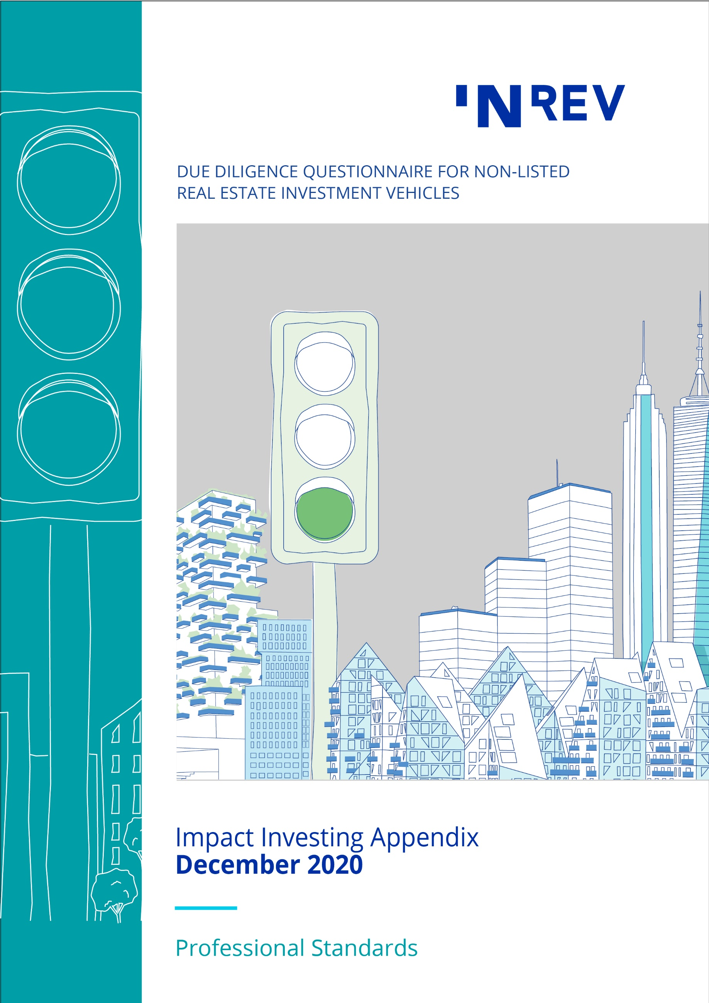

August 2014
Contents

Introduction 3
Impact Investing Questionnaire 5
1 Investment Manager Strategy 5
2 Vehicle Strategy 5

Introduction
ESG is becoming an integral part of a company’s strategic decision making. With ESG integration, investors systematically and explicitly include ESG factors into their financial analysis, risk assessment and monitoring of performance.
The INREV DDQ includes questions that facilitate the recognition of sustainability practices and encourages investment managers to highlight their concrete ESG plans and practical sustainability initiatives relating to their investment portfolios and their organisations.
As markets evolve, INREV now sees the increasing necessity for addressing impact investing in a separate DDQ Appendix. The Appendix is not mandatory to complete as part of INREV DDQ. Instead it aims to provide a tool for investment managers and investors to communicate information around impact investing strategies. However, if an investment manager decides to use and report on the INREV Impact Investing Appendix, this should be used in its full and complete form without amendment. INREV does not take any responsibility for the completion or any corrections of this Appendix.
Objective
Impact investments are investments made with the intention to generate positive, measurable social and environmental impact alongside a financial return.
As real estate investment managers have become increasingly keen to provide suitable products to meet institutional investors’ demand for real estate impact investments, INREV has been taken steps to provide more clarity and consistency in this important area. Supporting this evolution, INREV DDQ has been extended with an appendix specific to impact investing funds to help investors understand an impact investment fund’s strategy.
The objective of the Impact Investing Appendix of the DDQ is to provide insights in investment manager’s impact investment process and experience as well as impact objectives and measurement methodologies used for the specific vehicle and to allow investors to make well informed decisions in accordance with their social environmental impact objectives.
All investment have impact, could be positive or negative. An investment with positive impact is, however, not defined as impact investment unless it has clear investment criteria related to social or environmental factors and can demonstrate both additionality and intentionality. Therefore, INREV’s impact investing definition is highlighting 3 key factors; additionality, intentionality and measurement which is also embedded into the questionnaire.
The questionnaire is broken down into the following areas, containing 12 questions in total:
- Investment Manager Questions: This section focuses on organisation’s investment processes for impact investments and assesses organisation’s expertise in managing impact investments.
- Vehicle Level Questions: The following section dives into impact objectives of the specific vehicle, how the intended impact will be generated, how the additionality of the impact will be ensured, the details of the anticipated time-horizon of the impact, the impact measurement methodology and reporting processes.
For more information, please refer to impact investing definitions included in the Global Definition Database on the INREV website and to the INREV Spectrum for Investment, which is a framework to map out different investment approaches for real estate, depending on investors’ ambition for environmental and social impact, without imposing a rigid structure.

Impact Investing Questionnaire

1 Investment Manager Strategy

  - Does your organisation have an investment process for impact investments that the vehicle will adhere to? Describe the role of investment committee within the process.

1.2 Provide the details of your expertise as an investment manager in managing impact investments? Please provide examples. (If possible, indicate the percentage of the organisation's total investment portfolio and/or number of assets covered by its impact investment strategy.)

1.3 Are there any impact frameworks your organisation aligns to ? [e.g. the GIIN] (Linked to INREV DDQ 3.8.1 and 3.8.7)

2 Vehicle Strategy

Reference to INREV Definitions:
Impact Investing, Additionality, Intentionality, Impact Measurement and Management

2.1 Provide details of the intended impact that you are looking to generate with this investment vehicle. Explain how the intended impact will be generated.

2.2 Who or which groups of people or ecosystems are benefiting from the impact strategy of the vehicle?

2.3 What is the additionality of your investment vehicle is intending to create a positive impact through its investments? Explain how the additionality will be generated and assured.

2.4 Does your investment vehicle's impact and objectives align with the UN SDGs? Please describe which top 3 UN SDGs the investment vehicle targets and how.

2.5 What is the anticipated time horizon of the impact and does this amend the standard exit approach applied by you as an investment manager for non-impact investment strategies to achieve a responsible exit?

2.6 Explain how the impact will be measured (i.e. internally, independent third party, etc.) and what key performance metrics will be used to measure intended impact?

2.7 Describe the process and frequency used to report the progress in achieving the impact objectives into senior management and to the investors. (Linked to INREV DDQ 3.8.4)

2.8 How does this strategy differ as an ‘Impact Strategy’ from other strategies in your organisation investing in similar locations/ sectors?

2.9 Please describe how this investment strategy aligns to the INREV Spectrum of Investment. View the Spectrum of Investment.

