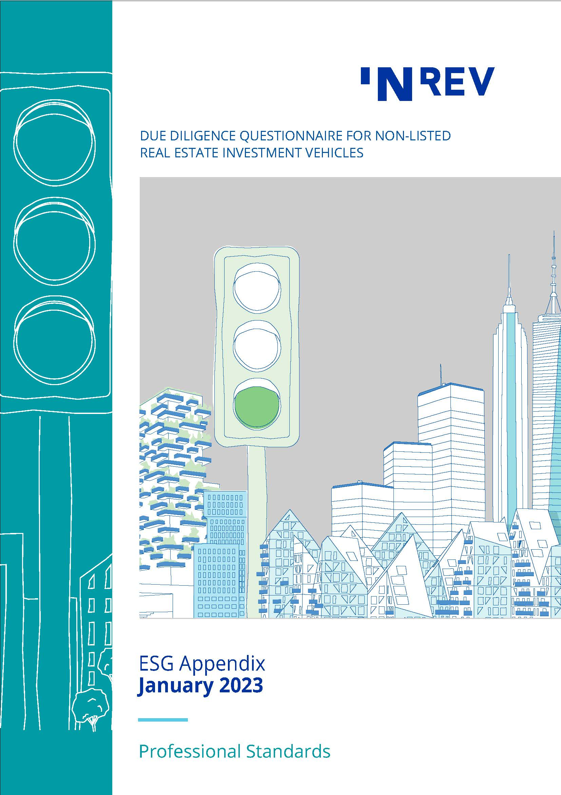

August 2014
Contents

Introduction 3
1 Climate Change Questions 4
1.0 Data Capture 4
1.1 Climate Change – Strategy and Objectives 4
1.2 Climate Change – Governance and Monitoring 4
1.3 Climate Change – Targets and Performance 5
1.4 Climate Change – Risks and Opportunities 5
1.5 Climate Change – Reporting 6
2 Social Aspects Questions 7
2.1 Social Aspects – Strategy and Objectives 7
2.2 Social Aspects – Governance and Monitoring 8
2.3 Social Aspects – Targets and Performance 11
2.4 Social Aspects – Risks and Opportunities 12
2.5 Social Aspects – Reporting 13
3 Other Questions 13
3.1 ESG 13
Appendix Tables 14
I. Policies on the Social Aspects of ESG 14
II. Stakeholder Engagement Initiatives 15

Introduction

ESG is becoming an integral part of a company’s strategic decision making. With ESG integration, investors systematically and explicitly include ESG factors into their financial analysis, risk assessment and monitoring of performance.
The INREV DDQ includes questions that facilitate the recognition of sustainability practices and encourages investment managers to highlight their concrete ESG plans and practical sustainability initiatives relating to their investment portfolios and their organisation.
INREV provides this separate ESG Appendix which covers in more detail specific ESG factors. The appendix is not mandatory to complete as part of INREV DDQ. Instead, it aims to provide a tool to communicate additional information around specific ESG topics which may be included and discussed, as applicable, during due diligence.
The ESG Appendix can be used by both real estate-specific and multi-asset type vehicles and their respective organisations. As markets evolve, INREV will consider expanding the questions in this appendix in line with market and regulatory developments as well as investor expectations.

Objective

The objective of the ESG Appendix is to assist investors and investment managers with a more granular level of analysis regarding their risk management efforts and strategies around specific ESG topics. The appendix focuses on two main themes: climate change and social aspects of ESG.
Climate Change
Climate change is seen as the biggest environmental challenge. There is a growing industry awareness and ambition to manage and mitigate physical risks of climate change and the risks associated with transition to a low carbon economy as well as navigate the opportunities resulting from climate change strategies.
Social Aspects
Social aspects cover a wide range of topics; from diversity, equity and inclusion to health, safety and wellbeing, from stakeholder engagement to human rights. Many of the social aspects discussed in this ESG Appendix are likely to be addressed at organisational level, hence the questions are designed to provide information at organisational level. On the other hand, vehicle-level questions were also added in each section to enable managers to explain their strategies, policies and actions for the specific vehicle, where necessary. The vehicle-level questions are applicable to different vehicle types and strategies, for example, irrespective of whether they have in place an impact investing strategy.

1 Climate Change Questions

1.0 Data Capture
Please indicate the percentage of the organisation's total investment portfolio and/or number of assets covered by the answers provided within this Climate Change Questions.

Reference to INREV definitions: Climate Risk, Physical Risk, Transition Risk.

Climate Change – Strategy and Objectives

1.1.1 Describe the organisation’s / vehicle's strategy and objectives in relation to assessing and managing climate risks. Explain why this is an appropriate strategy. (Linked to INREV DDQ 1.2.2 and 2.2.1)

Climate Change – Governance and Monitoring

1.2.1 Describe the organisation's / vehicle’s governance framework in relation to climate risk. (Linked to INREV DDQ 2.2.2)

1.2.1.1 Does the organisation have a process for communication and review of climate risks by the senior management? (Linked to INREV DDQ 2.2.2)

1.2.1.2 Who is responsible for coordinating the monitoring of climate change related issues at vehicle and organisation level? (Linked to INREV DDQ 2.2.2)

1.2.2 Please provide the main three actions or processes that are in place to incorporate an assessment of climate risks into the organisation's investment process.

Climate Change – Targets and Performance
Please see the INREV DDQ 2.2.3 for the main questions related to the overall ESG targets and performance.
1.3.1 Describe the organisation's targets in relation to carbon reduction. Please specify the policies/statements for the targets and the process of performance measurement against targets. (Linked to INREV DDQ 2.2.3.1)

1.3.2 Are there specific metrics used to ensure adaptation and mitigation of climate risks over time? Will these metrics include a 'Value at Risk' assessment a result of climate related risk and if so, how is this determined? (Linked to INREV DDQ 2.2.3.5)

Climate Change – Risks and Opportunities
Please see the INREV DDQ 2.2.4 for the main questions related to the overall climate change risk management.
1.4.1 What share of the standing investment portfolio and/or number of assets is located within 100-year flood zones? (100-year flood zones, also known as design flood, refers to the area that will be inundated by the flood event having a 1-percent chance of being equalled or exceeded in any given year. Ref: FEMA.) (Linked to INREV DDQ 2.2.4.4)

1.4.2 Are any key tenants or tenant groups significantly exposed to the impact of climate change related to properties under the vehicle’s portfolio? If yes, please explain the reasons behind the exposure and how you manage the physical and transition risks, including details of the controls in place. (Linked to INREV DDQ 2.2.4.3)

1.4.3 Has the energy performance level of the standing portfolio / asset been considered in the development of the long-term capex plan and its liquidity assumptions within the investment horizon, and if yes, how did it affect it? (Linked to INREV DDQ 2.2.5.4)

1.4.4 If a long-term decarbonisation pathway has been developed of the investment strategy, outline the pathway, the strategy to ensure the standing portfolio / asset performs in line with the pathway, how key milestones and success criteria has been set out. (Linked to INREV DDQ 2.2.4.5)

1.4.5 What specific actions have been implemented, or are planned to be implemented to minimise the impacts of the climate risk to the standing portfolio / asset?
Physical Risk:

Transition Risks:

Climate Change – Reporting

1.5.1 Describe the process and frequency used to report on climate related risk and performance into senior management and to the investors. (Linked to INREV DDQ 2.2.6)

1.5.2 What is the proposed framework for investor reporting on climate related risk and performance for this investment? (e.g. TCFD, GRESB, World GBC Advancing Net Zero initiative (ANZ), SASB, CDP etc.)

1.5.3 How will the assessment and management of climate related risks be incorporated into investor reporting on an ongoing basis?

1.5.4 Is the investment part of the adaptation or mitigation activities under the EU Taxonomy? If yes, how are the reporting requirements of the taxonomy proposed to be met by this investment?

Social Aspects Questions

Social Aspects – Strategy and Objectives

    - Does the organisation / vehicle have strategy and objectives on social aspects of ESG? If yes, please explain why this is an appropriate strategy and how it is integrated into the overall business strategy and investment decision making processes, or not. (Linked to INREV DDQ 1.2.1 and 2.2.1.1)
(An organisation / vehicle could have a separate strategy and objectives for a particular social aspect of ESG or it could be part of the overall ESG strategy)

      - Using the list below, please specify and explain the topics covered in the strategy:

- Diversity, Equity and Inclusion (DEI) (See INREV definition);

- Health, safety and wellbeing (HSW);

- Stakeholder Engagement (e.g. tenants, communities, employees);

- Employee Development;

- Human Rights;

- Social Impact;

- Other, please specify;

If not available, elaborate on which topics you intend to implement strategy and when.

    - In Appendix Table I, specify the policies adopted by the investment manager to address social issues via its investment strategies and portfolios (Linked to INREV DDQ 2.2.1.1).
If not available, elaborate whether or when you intend to implement policies to address social issues via investment strategies and portfolio.

    - Do the policies on social aspects adhere to widely recognised universal standards and principles? Please indicate what standards the policies on social aspects adhere to in the table below. (Linked to INREV DDQ Vehicle Fact Sheet)

Universal Standards / Principles | Comments
☐ Universal Declaration of Human Rights
☐ Declaration of ILO on Fundamental Principles and Rights at Work;
☐ UN Global Compact;
☐ UN Principles for Responsible Investment
☐ IFC Performance Standards
☐ OHSAS 18000
☐ ISO 14000
☐ UN Guiding Principles on Business and Human Rights
☐ OECD Guidelines for Multinational Enterprises
☐ UN Women Principles for Empowerment (WEP)
☐ The World Bank Group’s Environmental, Health, and Safety Guidelines
☐ The Equator Principles
☐ Other, please specify______________-

Social Aspects – Governance and Monitoring
    - Describe the governance framework in relation to monitoring and managing social aspects of ESG. (Linked to INREV DDQ 2.2.2)

    - Diversity, Equity and Inclusion (DEI)
      - How is the DEI policy implemented in the organisation? (Related to question 2.2.1.1)

      - Using the list below, please identify and refer to any DEI initiatives / programs at organisational level, if applicable. (Linked to INREV DDQ 2.2.1.1)
- Systems and procedures for recruiting diverse talent (e.g. scholarships/internships to increase the pool of diverse candidates)

- Systems and procedures for retaining diverse talent (e.g. well-defined and pre-determined criteria for employee evaluation, work-life balance programs such as parental leave);

- Systems and procedures to ensure equal pay for equal work (i.e. pay equity) (e.g. narrowing pay gaps, increase pay transparency);

- Providing diversity related trainings and development (e.g. programs to increase the number of women in the leadership pipeline, unconscious bias management, inclusive culture);

- Tracking DEI related outcomes (e.g. data collection, exit interview tracking, publishing DEI findings, feedback from stakeholders on DEI initiatives);

- Assessing DEI policy impact and obstacles to success;

- Supporting external diversity associations / activities (e.g. donating employee time / money to DEI non-profits, sponsoring DEI events);

- Having a DEI budget to promote DEI efforts;

- Organisation or an employee/team having or targeting DEI certification (please specify);

- Including non-executive surveyors into the investment process;

- Other, please specify;

If the organisation does not implement a DEI policy, please provide future initiatives related to DEI that you are planning.

      - Please indicate how DEI policies are implemented at vehicle level. Specify any DEI programs / initiatives at vehicle or asset level, if any.

      - Does the organisation have any initiatives to broaden business relationships with women-owned, minority-owned, disability-owned and/or emerging businesses? Please provide details of the program/initiative.

      - Has your organisation signed up to any industry wide DEI initiatives (e.g. Women Talk Real Estate, Real Estate Balance, Diversity Project)? If yes, please explain or include any other initiatives your organisation supports.

    - Health, Safety and Wellbeing (HSW)
      - How is the HSW policy implemented in the organisation or for the vehicle/assets? (Related to question 2.2.1.1)

      - Using the list below, please specify the actions/initiatives (including the ones specific to the vehicle) to improve HSW for the stakeholders. Specify if it is at organisational/vehicle/asset level. (Linked to INREV DDQ 2.2.1.1 and 2.2.5.3)
- Flexible working hours / working from home arrangements;

- Childcare facilities or contributions;

- Paid maternity/paternity leave (beyond legal requirements);

- Healthy eating;

- Inclusive design;

- Indoor air quality / water quality;

- Lighting adjustments / noise control;

- Access to physical activity;

- Access to physical and/or mental healthcare;

- Social interaction and connection;

- Other, please specify;

If the organisation does not implement a HSW policy, please provide future initiatives you are planning.

      - Please indicate how HSW policies are implemented at vehicle level. Specify any vehicle level HSW programs / initiatives, if any.

    - Stakeholder Engagement
      - Does the organisation have a stakeholder engagement program in place that includes issues specific to social aspects of ESG?

      - Using Appendix Table II, please specify the scope of the program. Refer to the initiatives applicable at organisational level and indicate which of these initiatives stakeholders are involved in.
For additional information, please use the comment box below (e.g. how often the program is reviewed, how you ensure your stakeholders are engaged with organisation's objectives on social aspects of ESG)
If not available, elaborate whether or when you intend to implement a stakeholder engagement program, using the comment box below.

      - Please indicate how stakeholder engagement policies are implemented at vehicle or asset level. Specify any vehicle or asset level stakeholder engagement programs / initiatives, if any.

Social Aspects – Targets and Performance

    - Does the organisation have specific targets in relation to its strategies/policies on social aspects of ESG. If yes, please explain. (Linked to INREV DDQ 2.2.3.1)

    - Does the organisation have a process to assess the performance against its targets on social aspects of ESG? If available, explain the process and whether the assessment on social aspects is integrated in the investment processes of the organisation.
If an assessment is not available, elaborate whether or when you intend to assess your organisation’s performance against its targets on social aspects of ESG.

      - Refer to INREV DDQ 2.2.3.5 to provide an overview of the targets and performance of the key social factors. Indicate the consequences of achieving or not achieving the target KPIs at organisational and vehicle level.

Social Aspects – Risks and Opportunities
    - Does the organisation have a process for identifying and monitoring the risks associated with its impact on society which could have a material financial impact on the organisation and its investments? If yes, please indicate the measures used and how often these risks are reviewed.

    - Does the organisation perform asset level assessments on social aspects as a standard part of its due diligence process for new acquisitions? If yes, specify the social issues covered with the assessment.

    - Does the organisation have processes to monitor property/asset managers’ compliance with its strategies/policies specific to social aspects of ESG? If yes, please explain how. Does this process apply for this specific vehicle?

    - Are there any issues, cases, settlements (past, present or pending) involving the organisation, employees, vehicles or portfolio companies on the topics listed below. If yes, please elaborate on the incident and when it happened. Comment if remedial action has been undertaken.
- Diversity, Equity and Inclusion (DEI);

- Health, safety and wellbeing (HSW);

- Human Rights (e.g. child labour, or any type of harassment) ;

- Other, please specify;

Social Aspects – Reporting
    - Does the investment manager have a process for communication its strategy on social aspects of ESG by the executive management? If yes, please explain how. (Linked to INREV DDQ 2.2.6)

    - Does the investment manager communicate its performance against the targets on social aspects with its stakeholders?

      - Describe the process to identify the social matters that are relevant and material to specific stakeholders. Specify which stakeholders are being reported on which social aspects of ESG.

      - Describe the process and frequency used to report on the targets and performance of the assessment of social aspects of ESG. Please state if you use a reporting framework (e.g., GRI 400 Standards).

Other Questions

ESG
    - Does the organisation have a process to monitor controversies, misconduct, penalties, or media news related to specific ESG factors affecting the organisation's reputation or the performance of the vehicle/assets? If yes, please explain.

Appendix Tables

Policies on the Social Aspects of ESG

Policies / Social Aspects Covered in a Policy | Scope of the Policy | Topics Covered in the Policy | Stakeholders Covered (As applicable)
DEI  ☐ Yes  ☐ No | ☐ Organisational Level  ☐ Vehicle Level | ☐ Diversity types  ☐ Gender / Gender Identity  ☐ Age  ☐ Race / Ethnicity  ☐ Physical Disability /Mental Health  ☐ Sexual Orientation  ☐ Other______  ☐ Impartiality within the procedures, processes, and resource distribution (e.g. Pay equity)  ☐ Inclusion in decision making (e.g. Board Diversity)  ☐ Other_________________ | ☐ Employees  ☐ Tenants / Customers  ☐ Communities  ☐ Suppliers  ☐ Other_________
HSW  ☐ Yes  ☐ No | ☐ Organisational Level  ☐ Vehicle Level | ☐ Occupational HSW  ☐ Mitigate health and safety risks  ☐ Improve design and construction of assets  ☐ Promote performance and productivity  ☐ Other________________ | ☐ Employees  ☐ Tenants / Customers  ☐ Communities  ☐ Suppliers  ☐ Other______
Stakeholder Engagement  ☐ Yes  ☐ No | ☐ Organisational Level  ☐ Vehicle Level | ☐ Cooperation with stakeholders  ☐ Continuous Communication  ☐ Improved stakeholder satisfaction  ☐ Minimised reputational risks  ☐ Other________________ | ☐ Employees  ☐ Tenants / Customers  ☐ Communities  ☐ Suppliers  ☐ Other________
Employee Development  ☐ Yes  ☐ No | ☐ Organisational Level  ☐ Vehicle Level | ☐ Employee development policies  ☐ Initiatives to support employees’ professional development / including employee development goals  ☐ Remuneration policies  ☐ Recruitment policies  ☐ Integrity of the compensation process  ☐ SROI policy*  ☐ Other_______________ | ☐ Employees  ☐ Tenants / Customers  ☐ Communities  ☐ Suppliers  ☐ Other_______
Human Rights  ☐ Yes  ☐ No | ☐ Organisational Level  ☐ Vehicle Level | ☐ Labour Rights  ☐ Preventing Child Labour  ☐ Preventing Human Trafficking  ☐ Preventing Forced / Compulsory Labour  ☐ Anti-harassment and/or anti-discrimination  ☐ Any others | ☐ Employees  ☐ Tenants / Customers  ☐ Communities  ☐ Suppliers  ☐ Any others
Other, please specify:_________ | ☐ Organisational Level  ☐ Vehicle Level | - | ☐ Employees  ☐ Tenants / Customers  ☐ Communities  ☐ Suppliers  ☐ Any others
*Social Return on Investment (SROI) is a method for measuring extra-financial value. It can be used to evaluate impact on stakeholders, identify ways to improve performance, and enhance the performance of investments.

Stakeholder Engagement Initiatives

Initiatives of the Stakeholder Engagement Program |  | Stakeholders the Initiative Applies to | Frequency
Satisfaction Surveys  ☐ Yes  ☐ No | A program in place to improve the survey results:  ☐ Yes  ☐ No | ☐ Employees  ☐ Tenants / Customers  ☐ Communities  ☐ Other_____________ | This initiative is undertaken within the last three years:  ☐ Yes  ☐ No
Trainings (on topics, such as anti-harassment, ethics, anti-bias behavior)  ☐ Yes  ☐ No | Indicate how many hours are dedicated per year:________ | (indicate % of stakeholders participated in this initiative over the last year)  ☐ Employees: ____%  ☐ Tenants / Customers: ____%  ☐ Communities:____%  ☐ Other: ____________% | This initiative is undertaken within the last three years:  ☐ Yes  ☐ No
Processes to communicate grievances/complaints (e.g. whistleblowing mechanisms)  ☐ Yes  ☐ No | Specify the characteristics of the process:_____________ | ☐ Employees  ☐ Tenants / Customers  ☐ Communities  ☐ Other:_______________ | This is an ongoing initiative:  ☐ Yes  ☐ No
Feedback sessions with stakeholders;  ☐ Yes  ☐ No | A program in place to follow up on the feedback received:  ☐ Yes  ☐ No | ☐ Employees  ☐ Tenants / Customers  ☐ Communities  ☐ Other:____________ | This initiative is undertaken within the last three years:  ☐ Yes  ☐ No
Community engagement programs  ☐ Yes  ☐ No | Specify the topics included:_____________ | - | This initiative is undertaken within the last three years:  ☐ Yes  ☐ No
Employee development program  ☐ Yes  ☐ No | Examples of the programs to facilitate the continued professional development: _______________  Social issues metrics are included in employee´s performance assessment and remuneration.  ☐ Yes  ☐ No  Professional development trainings to improve employees’ skill sets:  ☐ Yes  ☐ No | - | This is an ongoing initiative:  ☐ Yes  ☐ No
Exclusion criteria for activities with third parties (e.g. excluding companies violating human rights on tenant base or in supply chain);  ☐ Yes  ☐ No | Specify the exclusion criteria:_________________  The screening process is outsourced:  ☐ Yes  ☐ No  The exclusion criteria apply for this specific vehicle:  ☐ Yes  ☐ No  ☐ No, but other exclusion criteria apply:___________ | ☐ Employees  ☐ Tenants / Customers  ☐ Communities  ☐ Other:____________ | Specify the frequency of reviewing your exclusion criteria:_______________
Other, please specify_____________________ |  | ☐ Employees  ☐ Tenants / Customers  ☐ Communities  ☐ Other:____________ | Please specify_________

