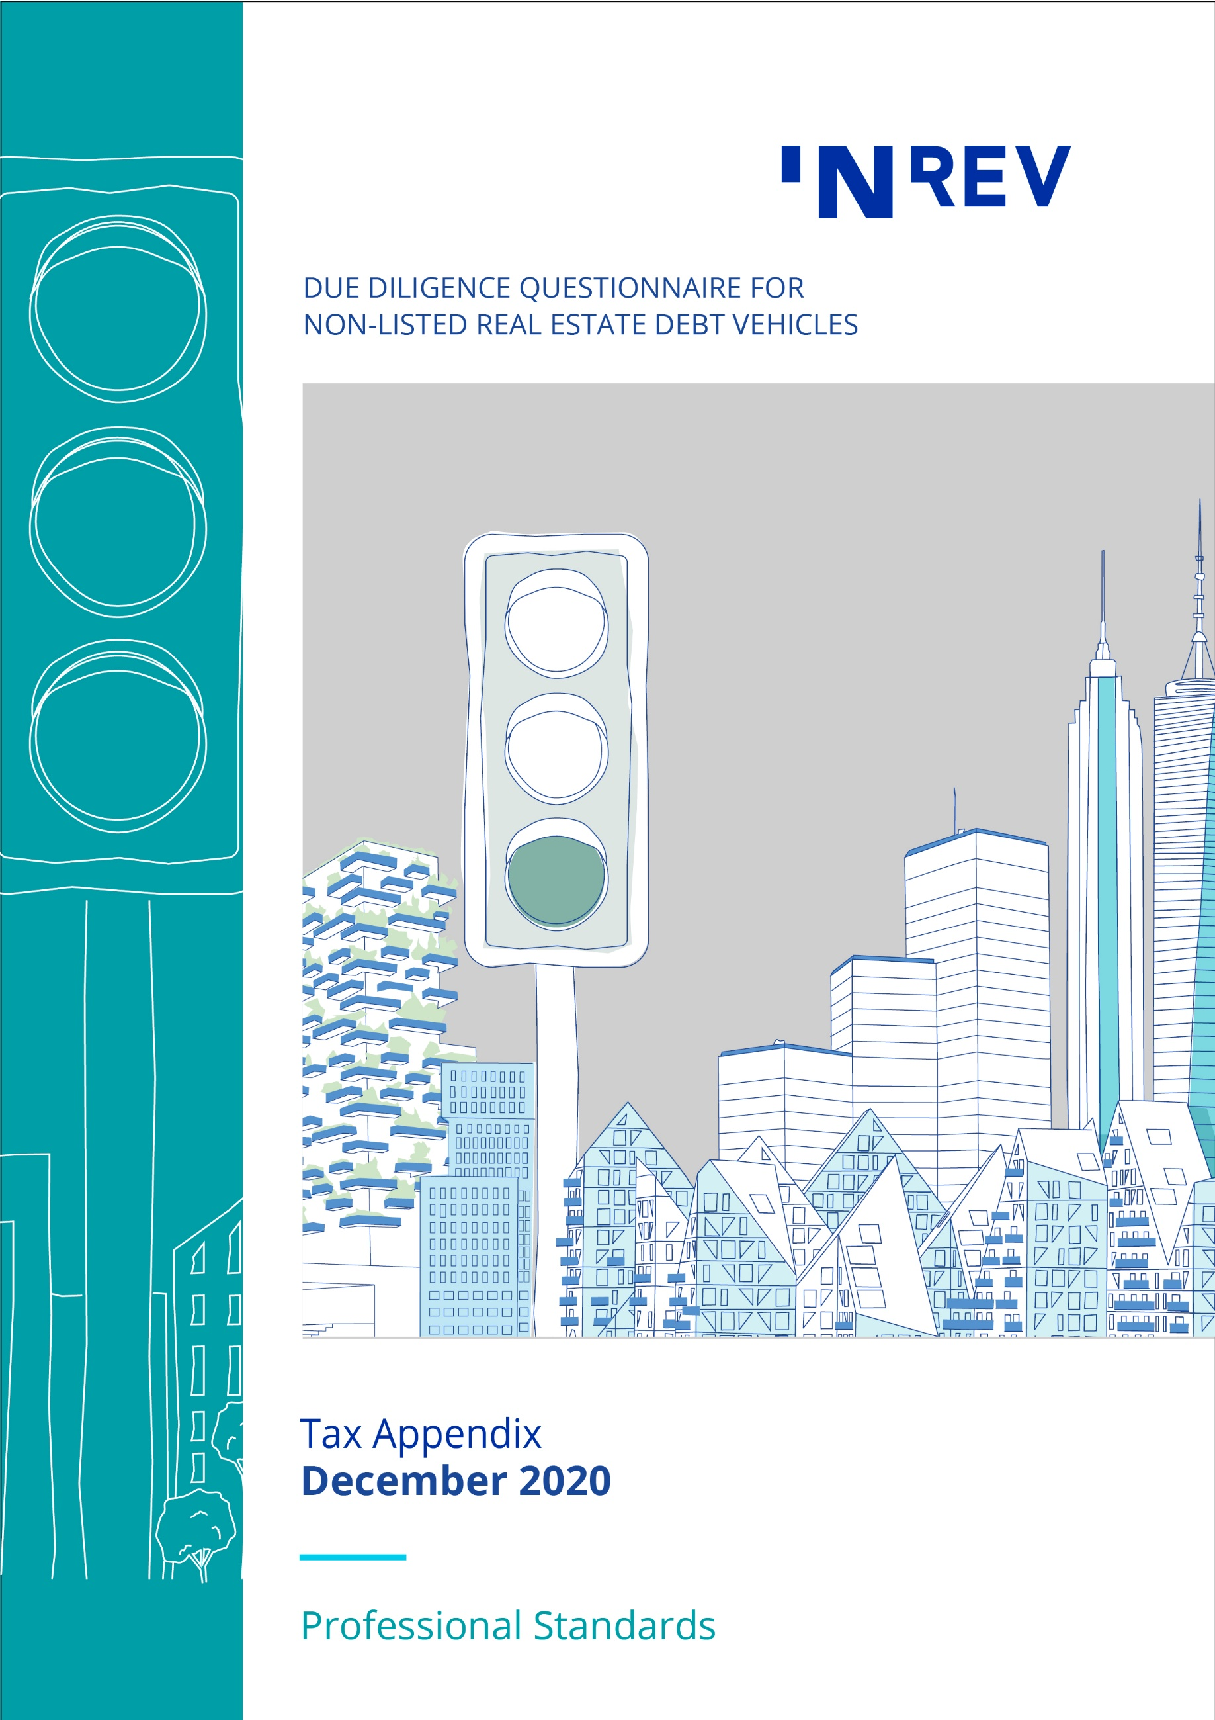

August 2014
Contents

1 Specific questions on taxation 3
2 Specific questions for US investors 5
3 Specific questions for German investors 6

1 Specific questions on taxation

1.1 General questions

1.1.1 Who is the tax advisor to the real estate debt vehicle and how is the tax advisor involved in the tax process?

1.1.2 What tax structure does the real estate debt vehicle have in place to ensure overall tax efficiency, compliance and risk control?

1.1.3 How does the real estate debt vehicle tax structure affect (projected) returns? Please elaborate on expected tax leakage.

1.1.4 Provide details of the methods for repatriation of profits and gains to the investors (dividends, interest payments, type of instrument used including qualification [debt/equity/financial instrument]) under domestic law. Investors
a Include details of any withholding taxes expected on these repatriations?

b Where repatriation mechanisms are used, can this create any beneficial ownership discussions?

1.1.5 Are there any significant changes expected (regulation/legal wise) for the planned tax structure?

1.1.6 Are any tax rulings required at either the vehicle level, in relation to the investment structure or at the investor level, and if so, have these been submitted and obtained?

1.2 Details in relation to the real estate debt vehicle(s)

1.2.1 Is the real estate debt vehicle regarded as tax transparent or as a separate taxable entity under the law of the country of establishment? If relevant, will the real estate debt vehicle(s) be regarded as tax transparent or not in the other countries of the investment structure?

1.2.2 If the real estate debt vehicle is a separate taxable entity:
a In which jurisdiction is it expected that this entity will be regarded as tax resident?

b What is the tax treatment of the real estate debt vehicle(s)? (corporate income tax [CIT], capital gains tax [CGT] and capital duty etc.)

c Will the substance requirements be met (now and in the future) in relation to securing tax residency in the preferred jurisdiction of the real estate debt vehicle(s) and how does the real estate debt vehicle ensure compliance?

1.2.3 How does the real estate debt vehicle ensure that entities in the vehicle structure will maintain sufficient substance and hold the investment so as to gain the benefits from double taxation treaties or EU directives (if available)?

1.2.4 What regulatory regime(s) is the real estate debt vehicle operating under and what approvals are required?

1.3 Details in relation to the investment structure

1.3.1 Provide a description of how the underlying investment loans are structured (i.e. legal status, capital structure, intermediate holding structure and local investment structure).

1.3.2 What is the tax treatment of the intermediate holding structure and local investment structure (all tax aspects of the entities which form part of the vehicle structure)?

1.3.3 Provide details of the funding of the investments and the tax treatment of the funding (e.g. interest deduction limitations, capital duty etc.).

1.3.4 Is there a permanent establishment risk due to the activities of the fund manager (e.g. GP etc.) in the countries where the real estate debt vehicle makes investments and in the other countries of the investment structure?

1.3.5 How does the real estate debt vehicle ensure that entities in its structure will not be considered to have a permanent establishment in a jurisdiction other than the jurisdiction of their respective establishment?

1.4 Other details in relation to the real estate debt vehicle

1.4.1 Specify any expected tax risks within the real estate debt vehicle e.g. clawback rules for tax purposes that may be applicable during the lifetime of the real estate debt vehicle (e.g. CIT, real estate transfer tax [RETT]), tax warranties etc.

1.4.2 Will the management fee be charged at vehicle level, investor level or at property company level? Will the most tax efficient routing be used for CIT and VAT purposes?

1.4.3 Are any deferred taxes taken into account when determining NAV? What methodology is used to calculate these deferred taxes?

2 Specific questions for US investors

Any US federal income tax advice implied by the following questions was not intended or written to be used, and it cannot be used by any person, for purposes of (a) avoiding any penalties that may be imposed by the US Internal Revenue Service (IRS) or (b) promoting, marketing or recommending to another party any transaction or matter to which the questions relate. If this advice is used or referred to by any person in promoting, marketing or recommending a partnership or other entity, investment plan or arrangement to any other person, then this advice was written to support the promotion or marketing of the transaction(s) or matter(s) to which the questions relate. All taxpayers should seek advice based on their own particular circumstances from an independent tax advisor.

2.1 Is the real estate debt vehicle regarded as tax transparent or as a separate taxable entity for US federal income tax purposes? If tax transparent, has a separate taxable entity (“blocker entity”) been set up for investing US tax-exempt entities?

2.2 Is the real estate debt vehicle a US or a non-US entity? If non-US, what is the level of US ownership of the vehicle?

2.3 Does the real estate debt vehicle generate any income from a trade or business that would be considered unrelated business taxable income (UBTI) for US federal income tax purposes (including any income generated from acquisition indebtedness)? Provide details of any measures that the real estate debt vehicle typically undertakes to prevent the generation of UBTI.

2.4 Has the real estate debt vehicle considered whether its underlying assets, or any of its investments, will be deemed to be “plan assets” for US Employee Retirement Income Security Act (ERISA) purposes? If so, please provide full details of whether or not the ERISA requirements are violated and a full description of the fiduciary responsibilities of the fund manager (if any).

2.5 Have any US “check-the-box elections” ever been made on behalf of the real estate debt vehicle or any of its portfolio companies to treat a specific entity differently for US federal income tax purposes than for local legal, financial or tax purposes? If so, please provide full details.

2.6 Has the real estate debt vehicle ever filed a US federal, state, or local tax return?

2.7 Does the real estate debt vehicle or any of the companies in which the real estate debt vehicle has a direct or indirect interest expect to be classified as a Controlled Foreign Corporation (CFC), Controlled Foreign Partnership (CFP) or a Passive Foreign Investment Company (PFIC) for US federal income tax purposes? Is the real estate debt vehicle required and able to produce the respective information to its US investors to satisfy the CFC, CFP and PFIC reporting requirements? Is the real estate debt vehicle willing to prepare the relevant forms (e.g. 8865, 5471) on behalf of its investors?

2.8 Is the real estate debt vehicle required to provide Schedule K-1 type information to its US investors? If so, what is the real estate debt vehicle’s timing for providing this information?

2.9 Does (or will) the real estate debt vehicle hold any investments in US assets? If so, what types of US assets (e.g. shares, interests in flow-through entities, real property, US real estate investment trust [REITs])?

2.10 What is the real estate debt vehicle’s policy with regard to recognition of foreign exchange gains and losses under Section 987 of the US Internal Revenue Code? Is the real estate debt vehicle required and able to produce the respective information to its US investors to satisfy any reporting requirements?

3 Specific questions for German investors

3.1 Does the German Investment Tax Act (Investmentsteuergesetz) apply to any real estate debt vehicle(s) in which a German investor will hold a direct or indirect interest?

3.2 If so, will such real estate debt vehicle(s) be able to provide the relevant tax reporting under the German Investment Tax Act and bear the costs?

3.3 Does any real estate debt vehicle qualify as a special fund (Spezialfonds) under the provisions of the German Investment Tax Act (Investmentsteuergesetz)?

3.4 If the German Investment Tax Act does not apply;
a Are the real estate debt vehicle(s) regarded as tax transparent or as separate taxable entities under German tax law?

b What is the tax treatment of the real estate debt vehicle(s) under German tax law??

c Will the real estate debt vehicle be able to file the appropriate tax returns with the German tax authorities, if necessary?

3.5 Separately considering any source state, who will in each case be entitled to claim for treaty benefits and the reimbursement of potential withholding taxes on profits directly or indirectly derived under a double-tax treaty?

3.6 Is the real estate debt vehicle able to satisfy the necessary regulatory requirements under German law i.e.
a Does the real estate debt vehicle qualify as an eligible investment for the restricted reserves of German insurance companies, pension funds and professional pension schemes:
I Under the real estate quota (Immobilienquote)?

II Under the participation quota (Beteiligungsquote)?

III As qualifying target real estate debt vehicle under the real estate quota according to the proposed new section 2 paragraph 14c) Investment Ordinance (Anlageverordnung)?

b Is the real estate debt vehicle an eligible investment for German Spezialfonds under the German Investment Act (Investmentgesetz)?

3.7 Will the real estate debt vehicle provide an expert opinion regarding questions 1, 3, 4 and 5 above?

3.8 Does the real estate debt vehicle provide a VAG (Versicherungsaufsichtsgesetz) – reporting according to VAG §54 d? (the reporting is required by insurance & pensions funds).

